Marital Status Changes
Marital Status Changes can be made by Right clicking this link and opening in a new tab: Marital Changes

- Click Add An Action 2. Click Other
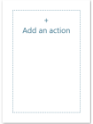
- Click Marital Status Update
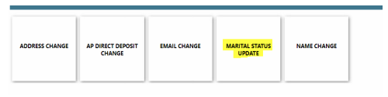
- Click Single or Married
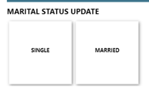
- Enter the date of the Marital Status change. Documentation is optional. Click Submit
